**ASSIGMENT OF HIVE:**

**Task1 :**

1**.1 Below command starts the hive and take us to the hive shell**

**>hive**

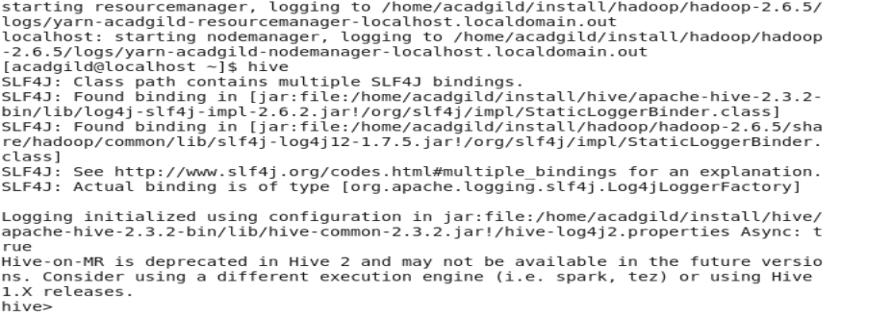

**Below command will create a database with the name CUSTOM:=**

**>CREATE DATABASE CUSTOM;**

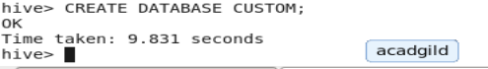

Instructing to use the CUSTOM database

**>USE CUSTOM;**

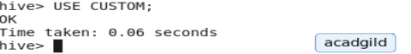

Creating a temporary table in which we will load the data of the dataset as its date format is not in the hive date format,

Also taking the DATES column as string to manipulate it using cast function.

**CREATE TABLE TMP(DATES STRING,ZIPCODE STRING,TEMPERATURE INT) ROW FORMAT DELIMITED FIELDS TERMINATED BY ‘,’;**

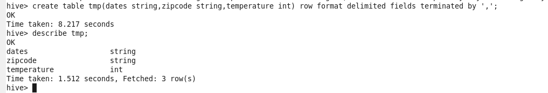

Loading data into the file using the dataset:-

**LOAD DATA LOCAL INPATH ‘hive_dataset.txt’ overwrite into table TMP;**

Create the TEMPERATURE_DATA table:-

**CREATE TABLE TEMPERATURE_DATA(DATES STRING,ZIPCODE STRING,TEMPERATURE INT) ROW FORMAT DELIMITED FIELDS TERMINATED BY ‘,’;**

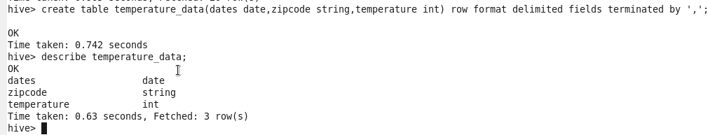

Insert into the TEMPERATURE-DATA table using the TMP table:-

**INSERT INTO TABLE TEMPERATURE_DATA SELECT cast(to_date(from_unixtime(unix_timestamp(DATES, 'dd-MM-yyyy'))) as date) ,ZIPCODE,TEMPERATURE FROM TMP;**

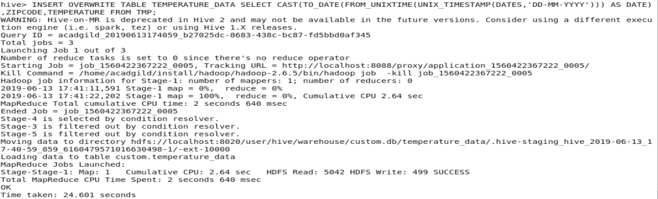

**Task 2:**

**Below command will fetch the temperature where the zipcode is greater than 300000 and less than 399999;**

**SELECT * FROM TEMPERATURE_DATA WHERE ZIPCIDE>300000 AND ZIPCIDE<399999;**

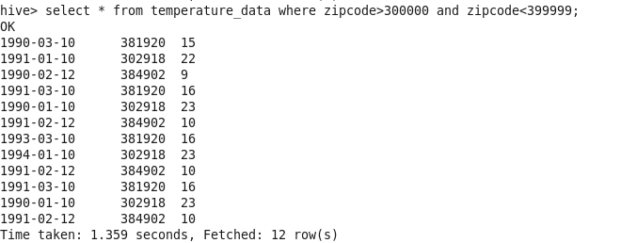

**Below command will fetch the maximum temperature of each year:-**

**SELECT MAX(TEMPERATURE),YEAR(DATES) FROM TEMPERATURE_DATA GROUP BY YEAR(DATES);**

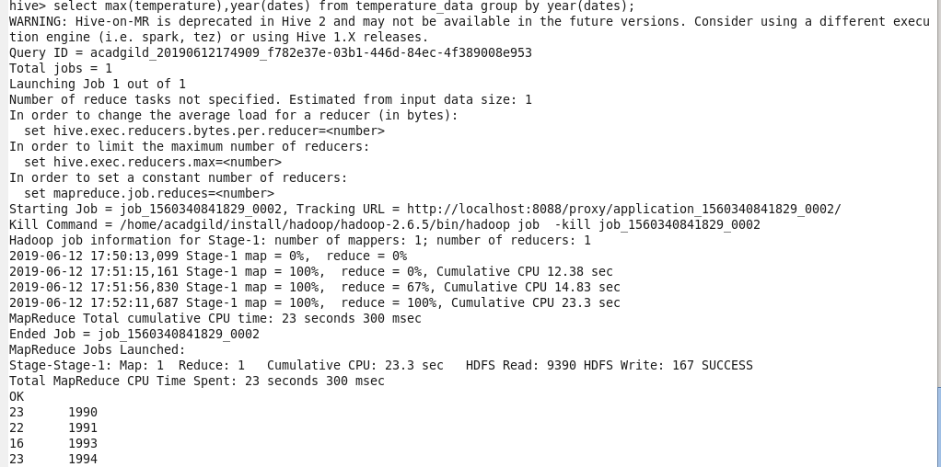

**Below command will fetch the maximum temperature of each year having at least two entries:-**

**SELECT MAX(TEMPERATURE),YEAR(DATES) FROM TEMPERATURE_DATA GROUP BY YEAR(DATES)**

**HAVING COUNT(1)>=2;**

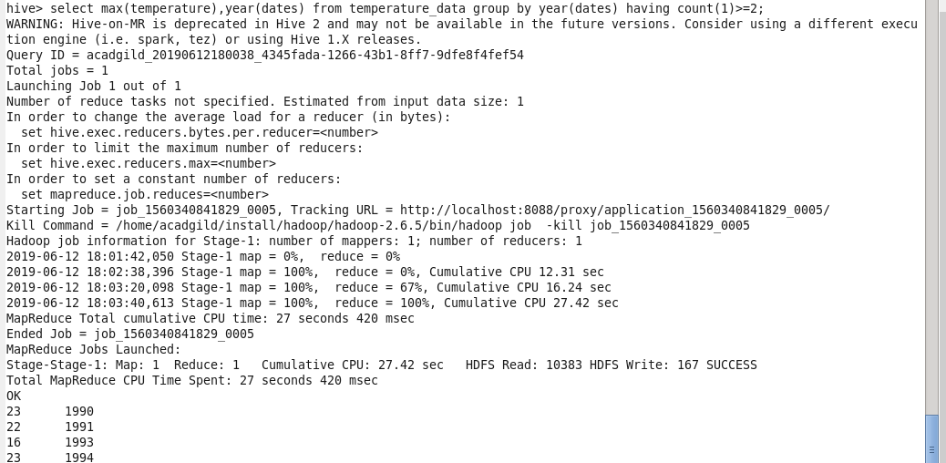

**Below command creates the view on max temperature of each year having at least two entries:-**

**CREATE VIEW TEMPERATURE_DATA_VW AS SELECT MAX(TEMPERATURE),YEAR(DATES) FROM TEMPERATURE_DATA GROUP BY YEAR(DATES) HAVING COUNT(1)>=2;**



**BELOW COMMAND WILL EXPORT THE CONTENT OF THE VIEW INTO /HOME/ACADGILD/OUT FOLDER:-**

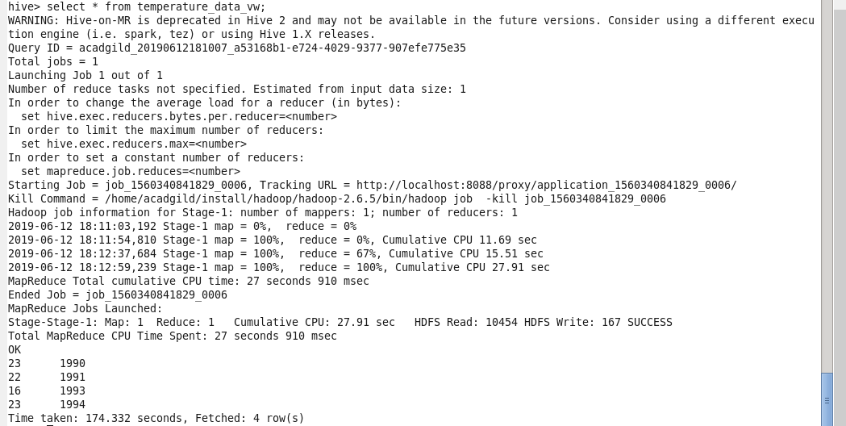

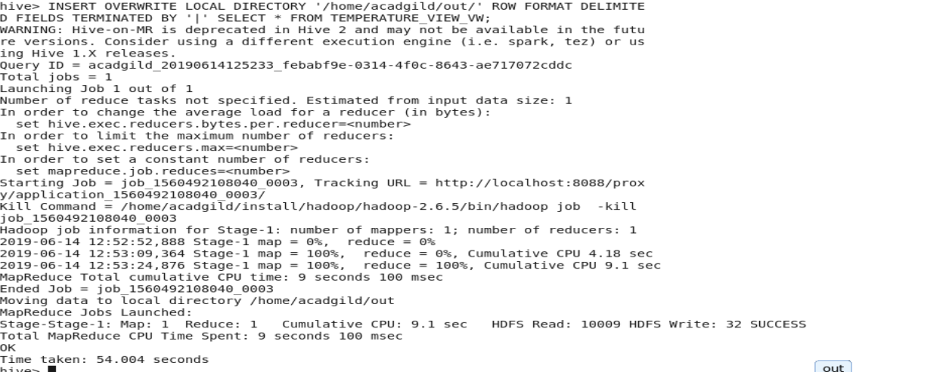

**Output of the file created in the local file system:-**

